**Instructions:**Replace **[bracketed red text]** with the requested information or screen capture.  
Replace **bracketed red text with black text**.  
**PLEASE do not include full page, full window screen shot images**, or full screen shots that have been reduced in size.   
Use a snippet tool to capture parts of the screen and insert those images into the template.  
**Do not remove tags from this template. An example of a tag is [C01]. All fields are required.***Please do not alter template formatting or delete parts of this template.*

Part A - Student Information:  **1. Student Name: Abel Marin  
2. Student Contact Info: (630) 608-8570 marinabe1416@gmail.com**

Go back to the instructions and continue with Part B.  
Part B – Drupal CMS Website and Web Host Information:

**Part B.1 – Drupal 8 on a Shared web host**

1. Enter the following shared web host Drupal site information **[B.1.1]**
   1. Shared Web Host Company Name: [ SiteGround ]
   2. In Directory Name: [ mod07assign07 ]
   3. Website Admin Username: [ ajmarin ]
   4. Website Admin Password: [ 38@E1DbV&@ ]
   5. Database Name: [ drmn_]
   6. Table Prefix: [ drup720]

**Part B.2 – Drupal 8 on Pantheon (PaaS)**

1. Enter the following shared web host Drupal 8 site information **[B.2.1]**
   1. PaaS Drupal 8 Front end site URL: [ website URL here ]
   2. PaaS Drupal 8 site Admin Username: [ website admin username here ]
   3. PaaS Drupal 8 site Admin Password: [ website admin password here ]

**Part B.3 – Drupal 8 on Codeanywhere**

1. Enter the following Codeanywhere web host Drupal 8 site information **[B.3.1]**
   1. Codeanywhere account username(email): [marinabe1416@gmail.com]
   2. Codeanywhere account password: [Dbeu!315]
   3. Site Title: [ CA Assignment 7 ]
   4. Username: [ ajmarin ]
   5. Password: [ **Dbeu!315!315** ]

Go back to the instructions and continue with Part C.

Part C – Extending Drupal 8 with Core Modules  
  
Drupal 8 Screen Captures:

1. SCREEN CAPTURE – Backend Admin toolbar > Extend with CORE Contact module visible. [C01][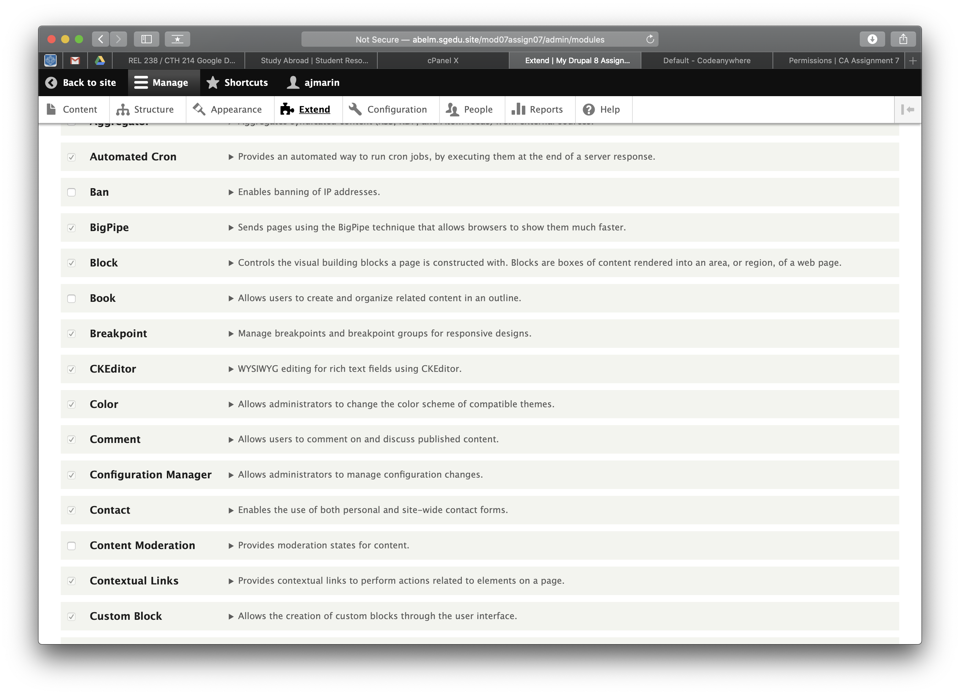]
2. SCREEN CAPTURE – Backend Admin toolbar > People > Permissions – with the Contact module permissions visible.   
   [C02][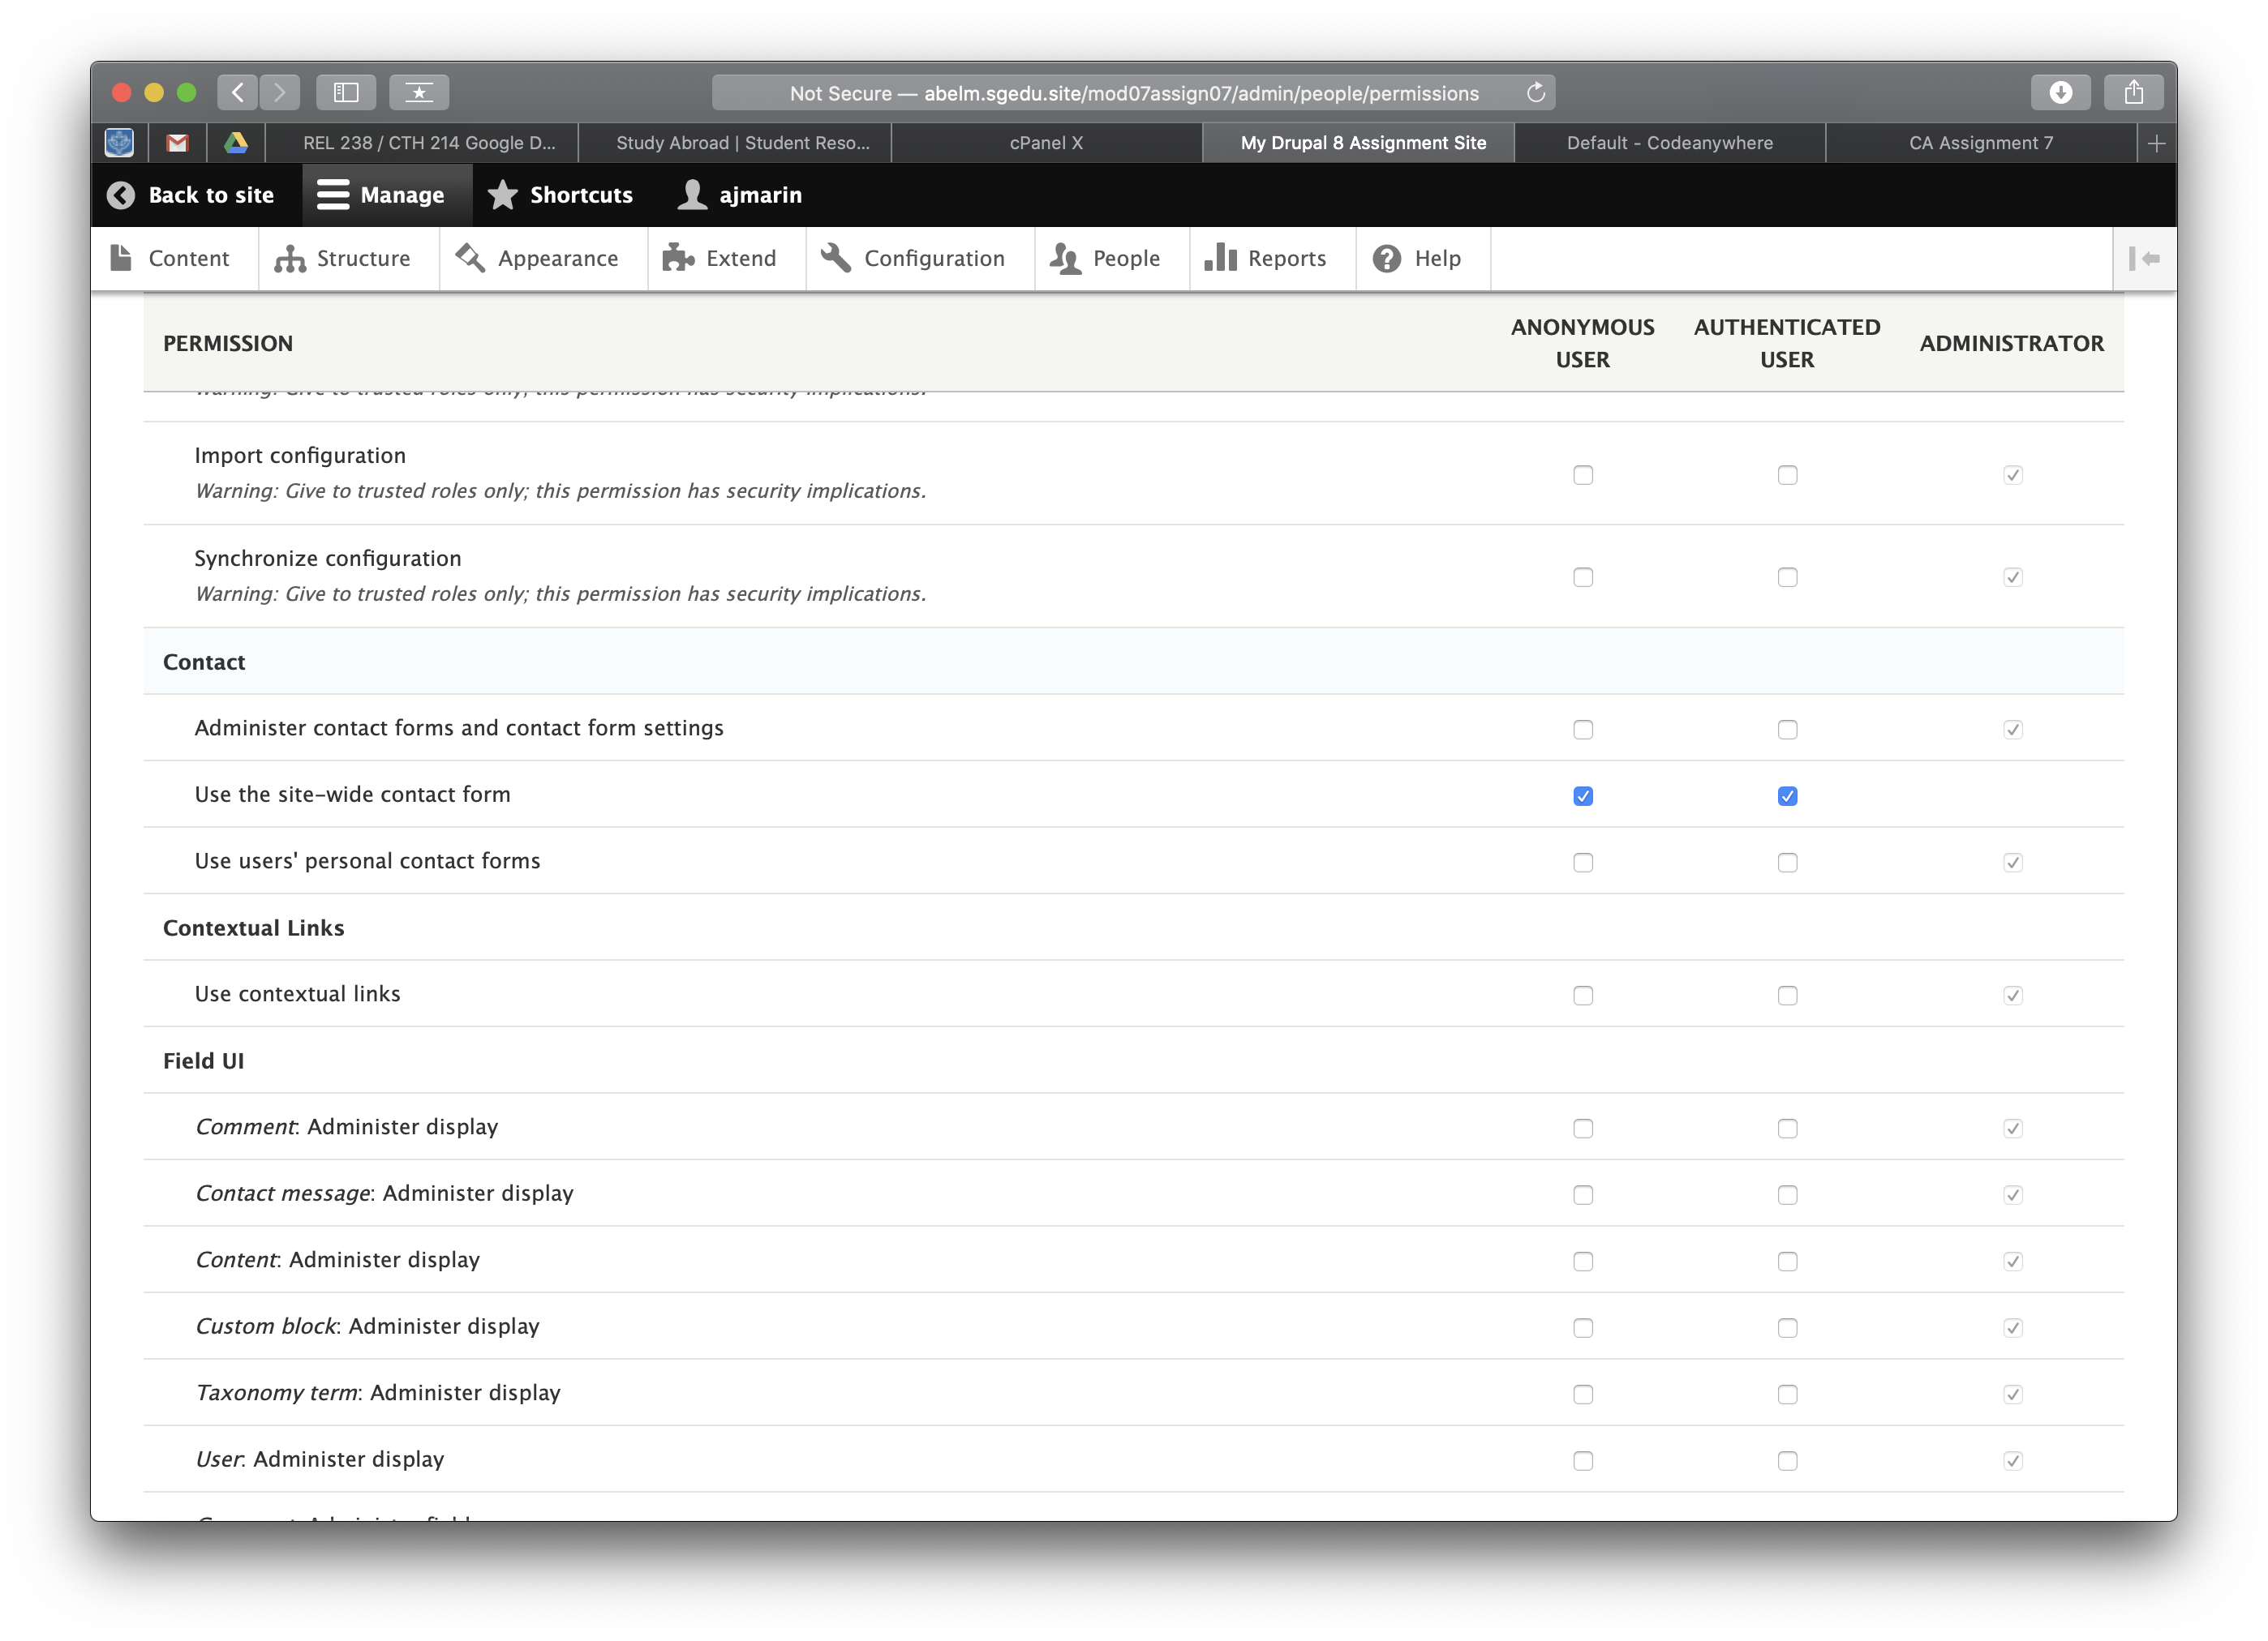]

Part D – Extend Drupal 8 with Contributed Modules – All Platforms

1. SCREEN CAPTURE – Backend Admin toolbar > Extend with FAQ module visible  
   [D01][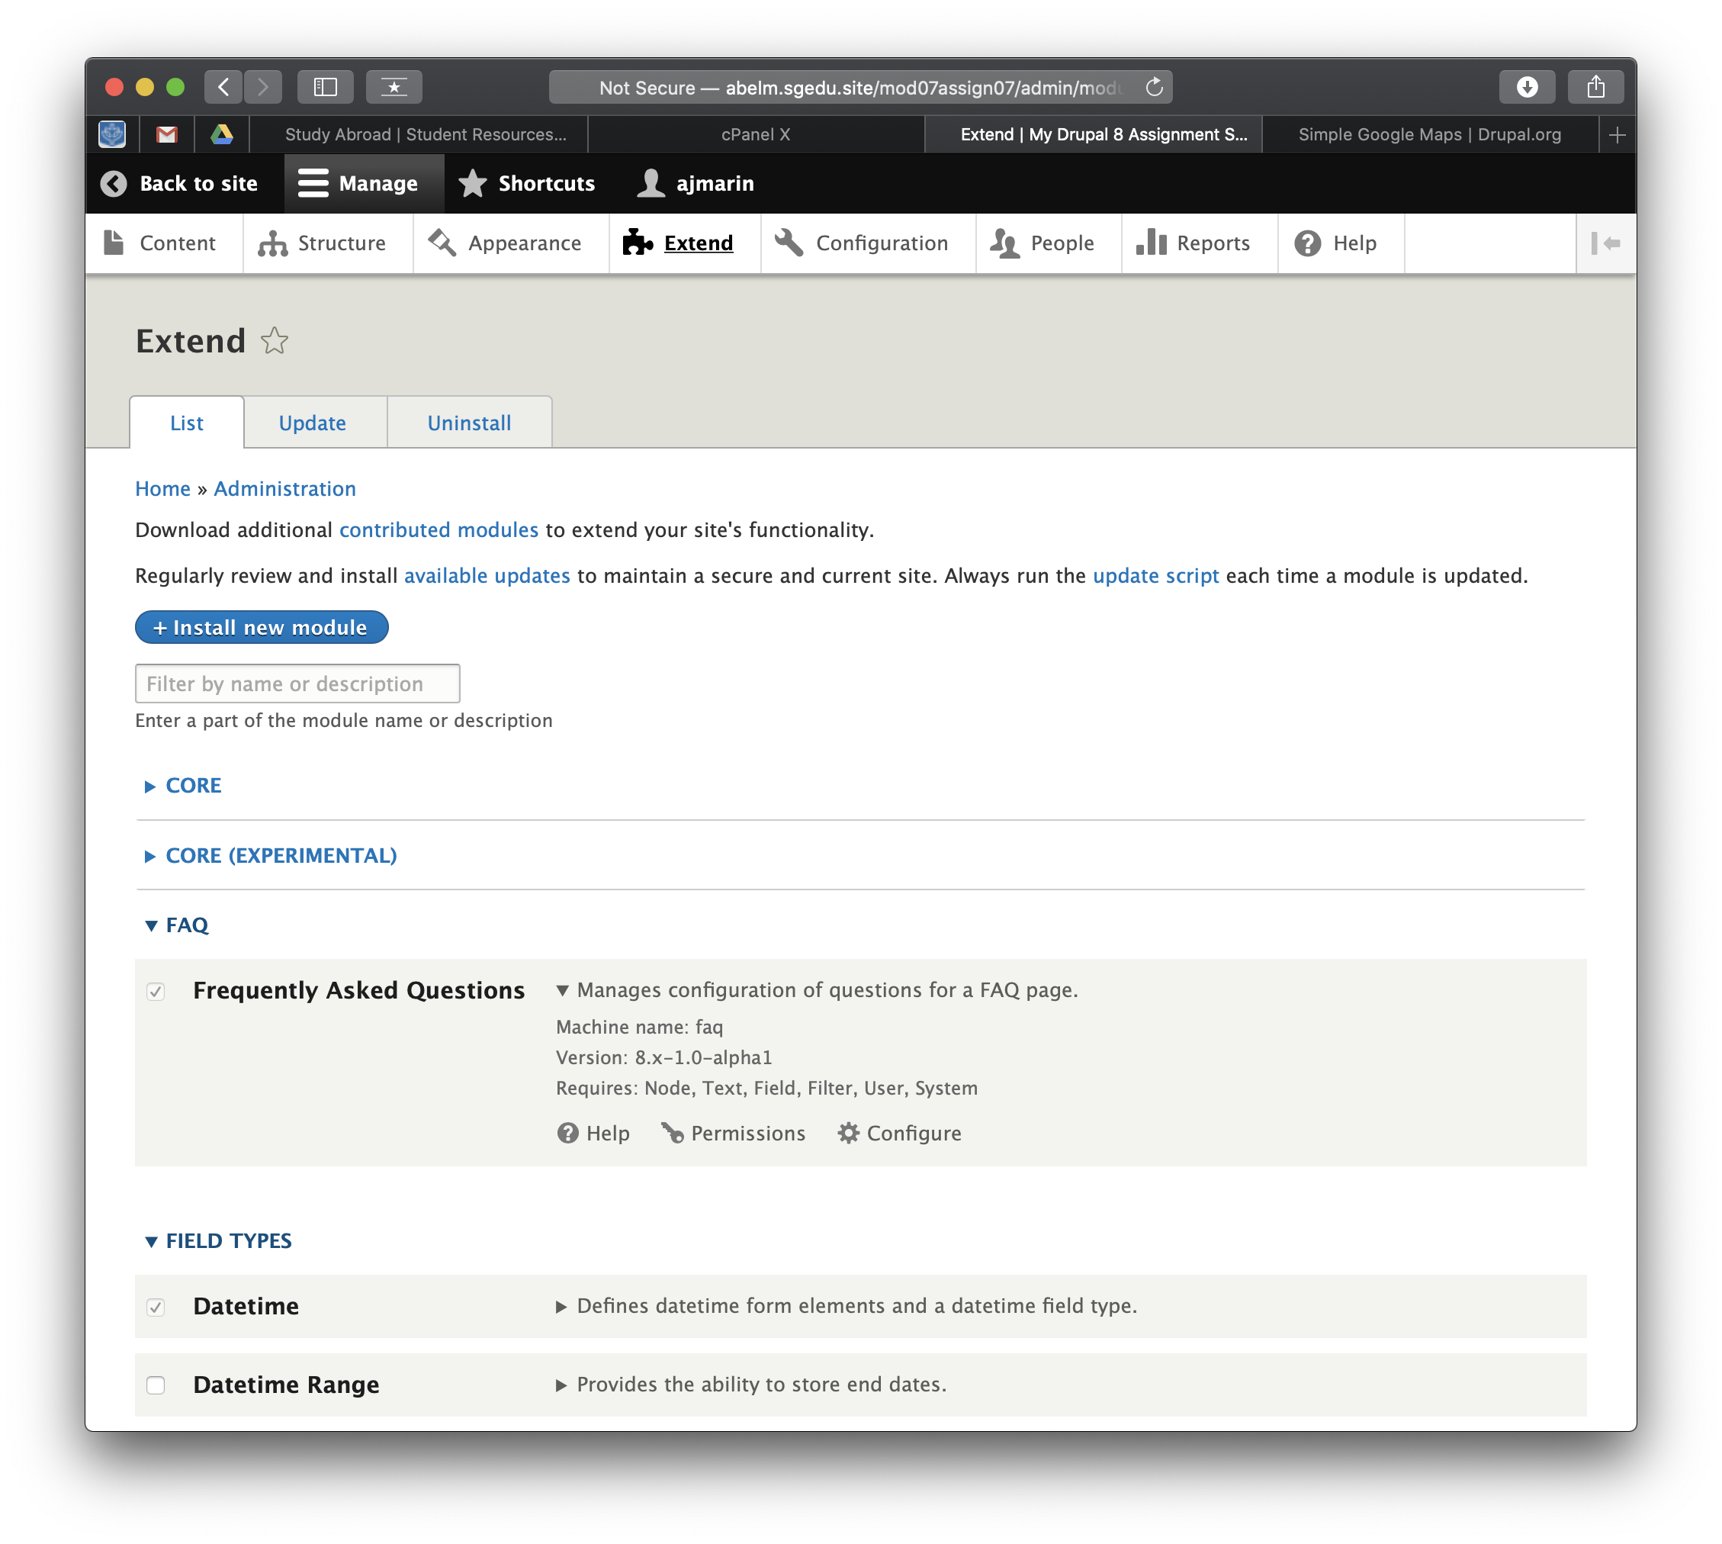]
2. SCREEN CAPTURE – Backend Admin toolbar > Extend with Map module visible.   
   [D02]  
   [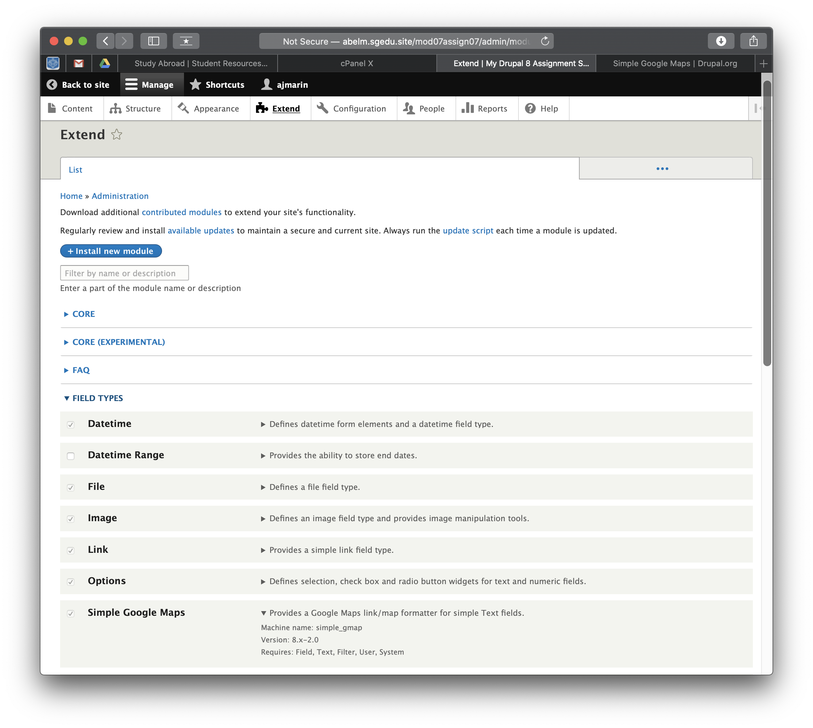]
3. SCREEN CAPTURE – Front End (on a different web browser where you not logged in as the site admin) FAQ page selected. Please make sure the screen capture has the web browser address bar and one FAQ item selected and expanded.   
   [D03]  
   [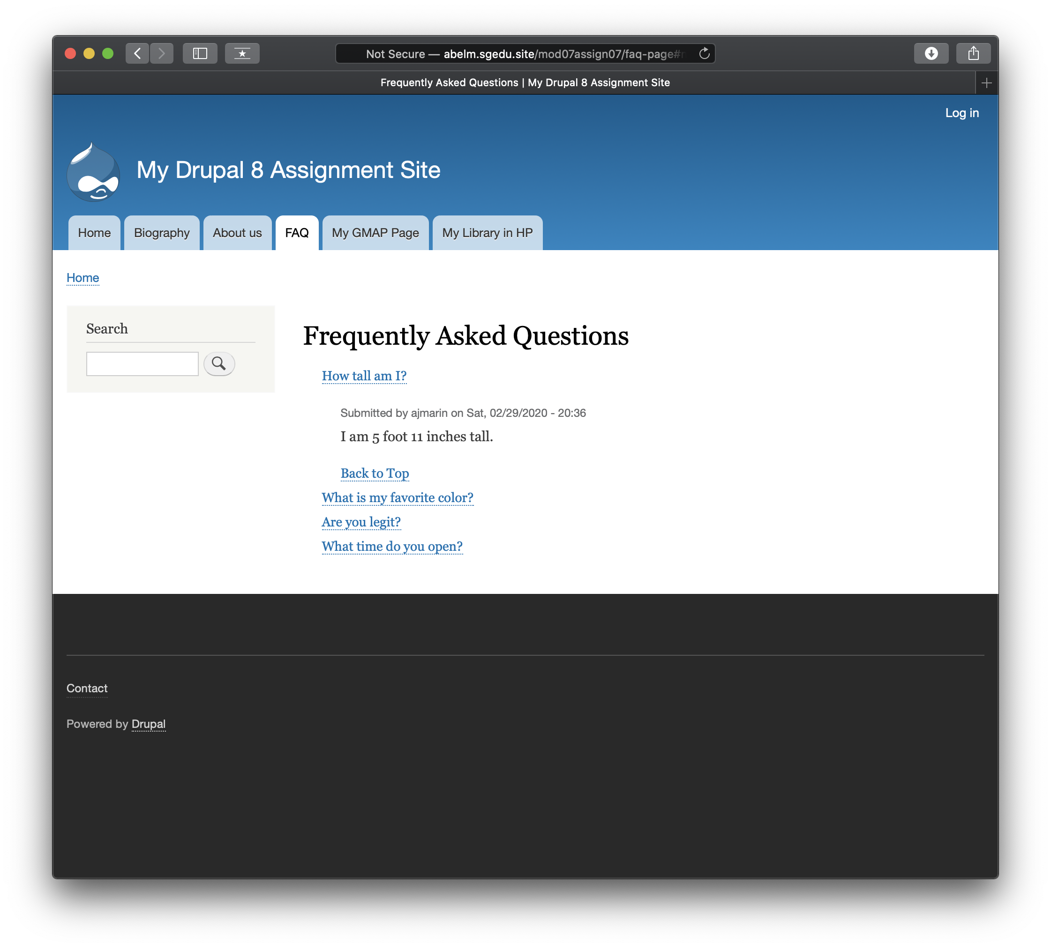]
4. SCREEN CAPTURE – Front End (on a different web browser where you not logged in as the site admin) Map page selected. Please make sure the screen capture has the web browser address bar.  
   [D04]  
   [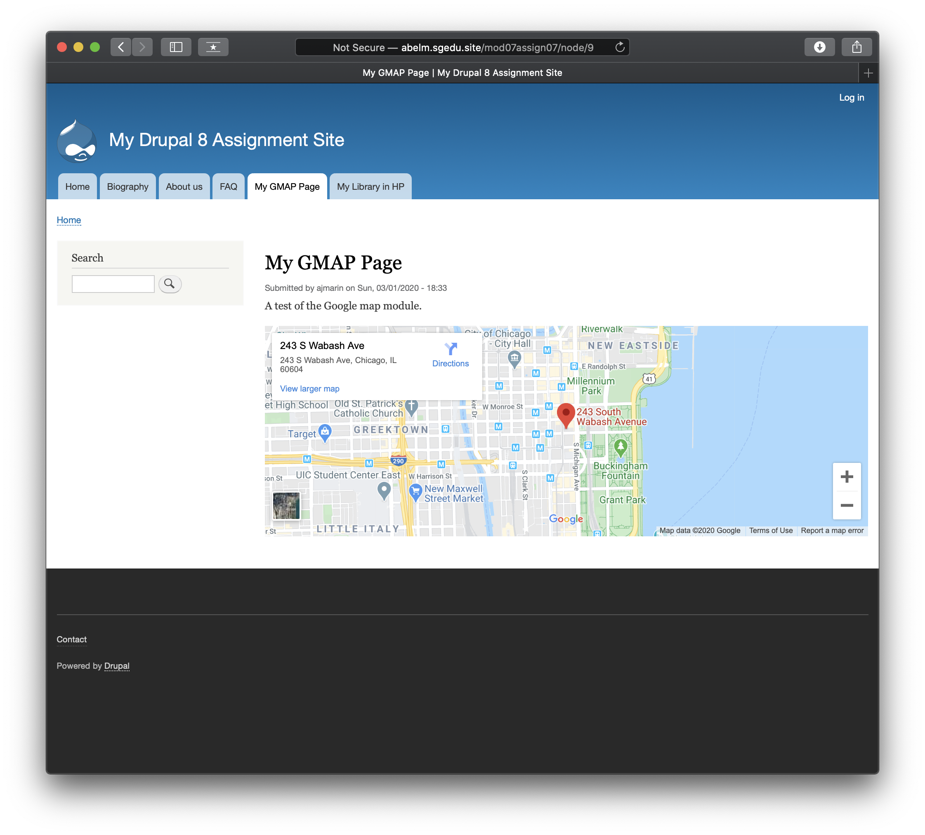]
5. Go back to the instructions and continue with Part E

Part E – Extend Drupal 8 with Custom Modules – All Platforms

1. Shared web host - SCREEN CAPTURE of the backend with the “/hello/world” appended to the base site URL with the web browser address bar on the picture. [E01][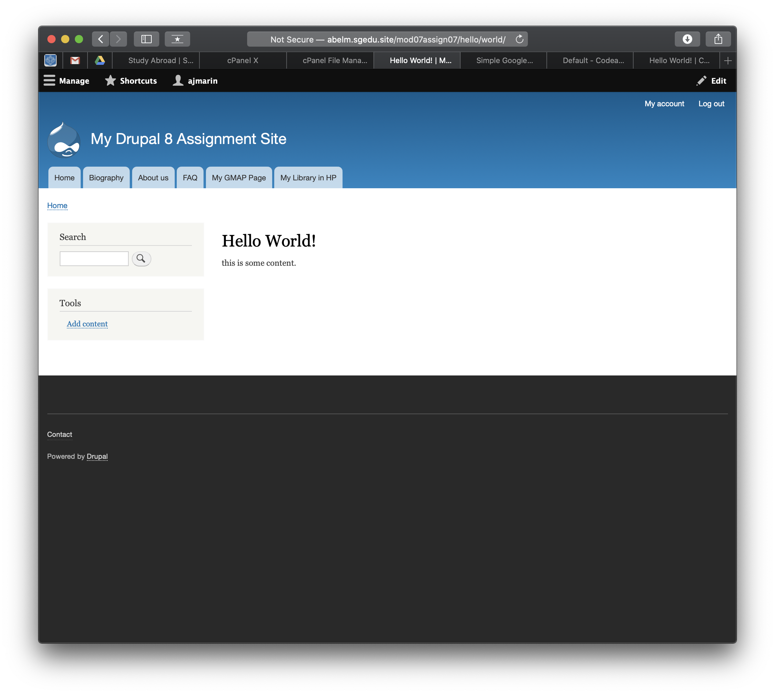]
2. Shared web host – cPanel FILE > File Manager – take a screen capture of the custom module folder fully expanded. [E02][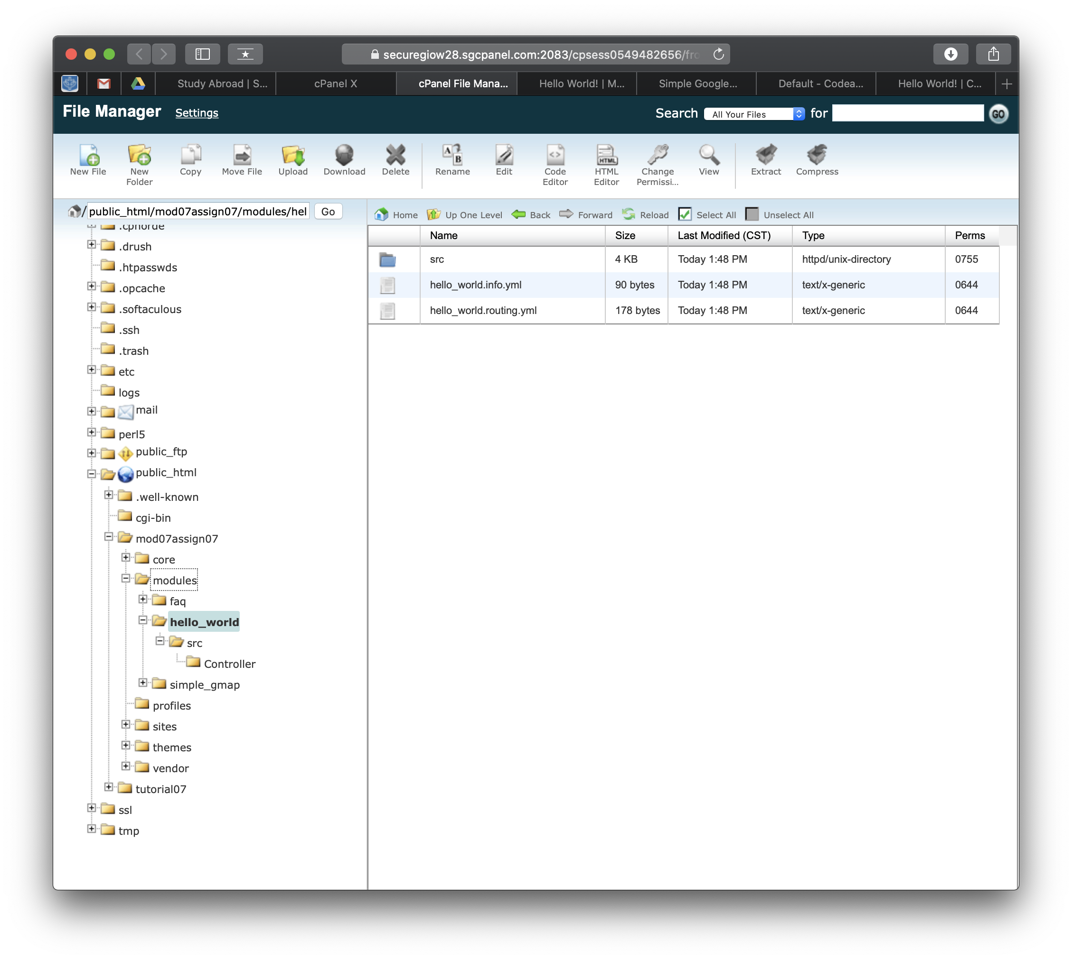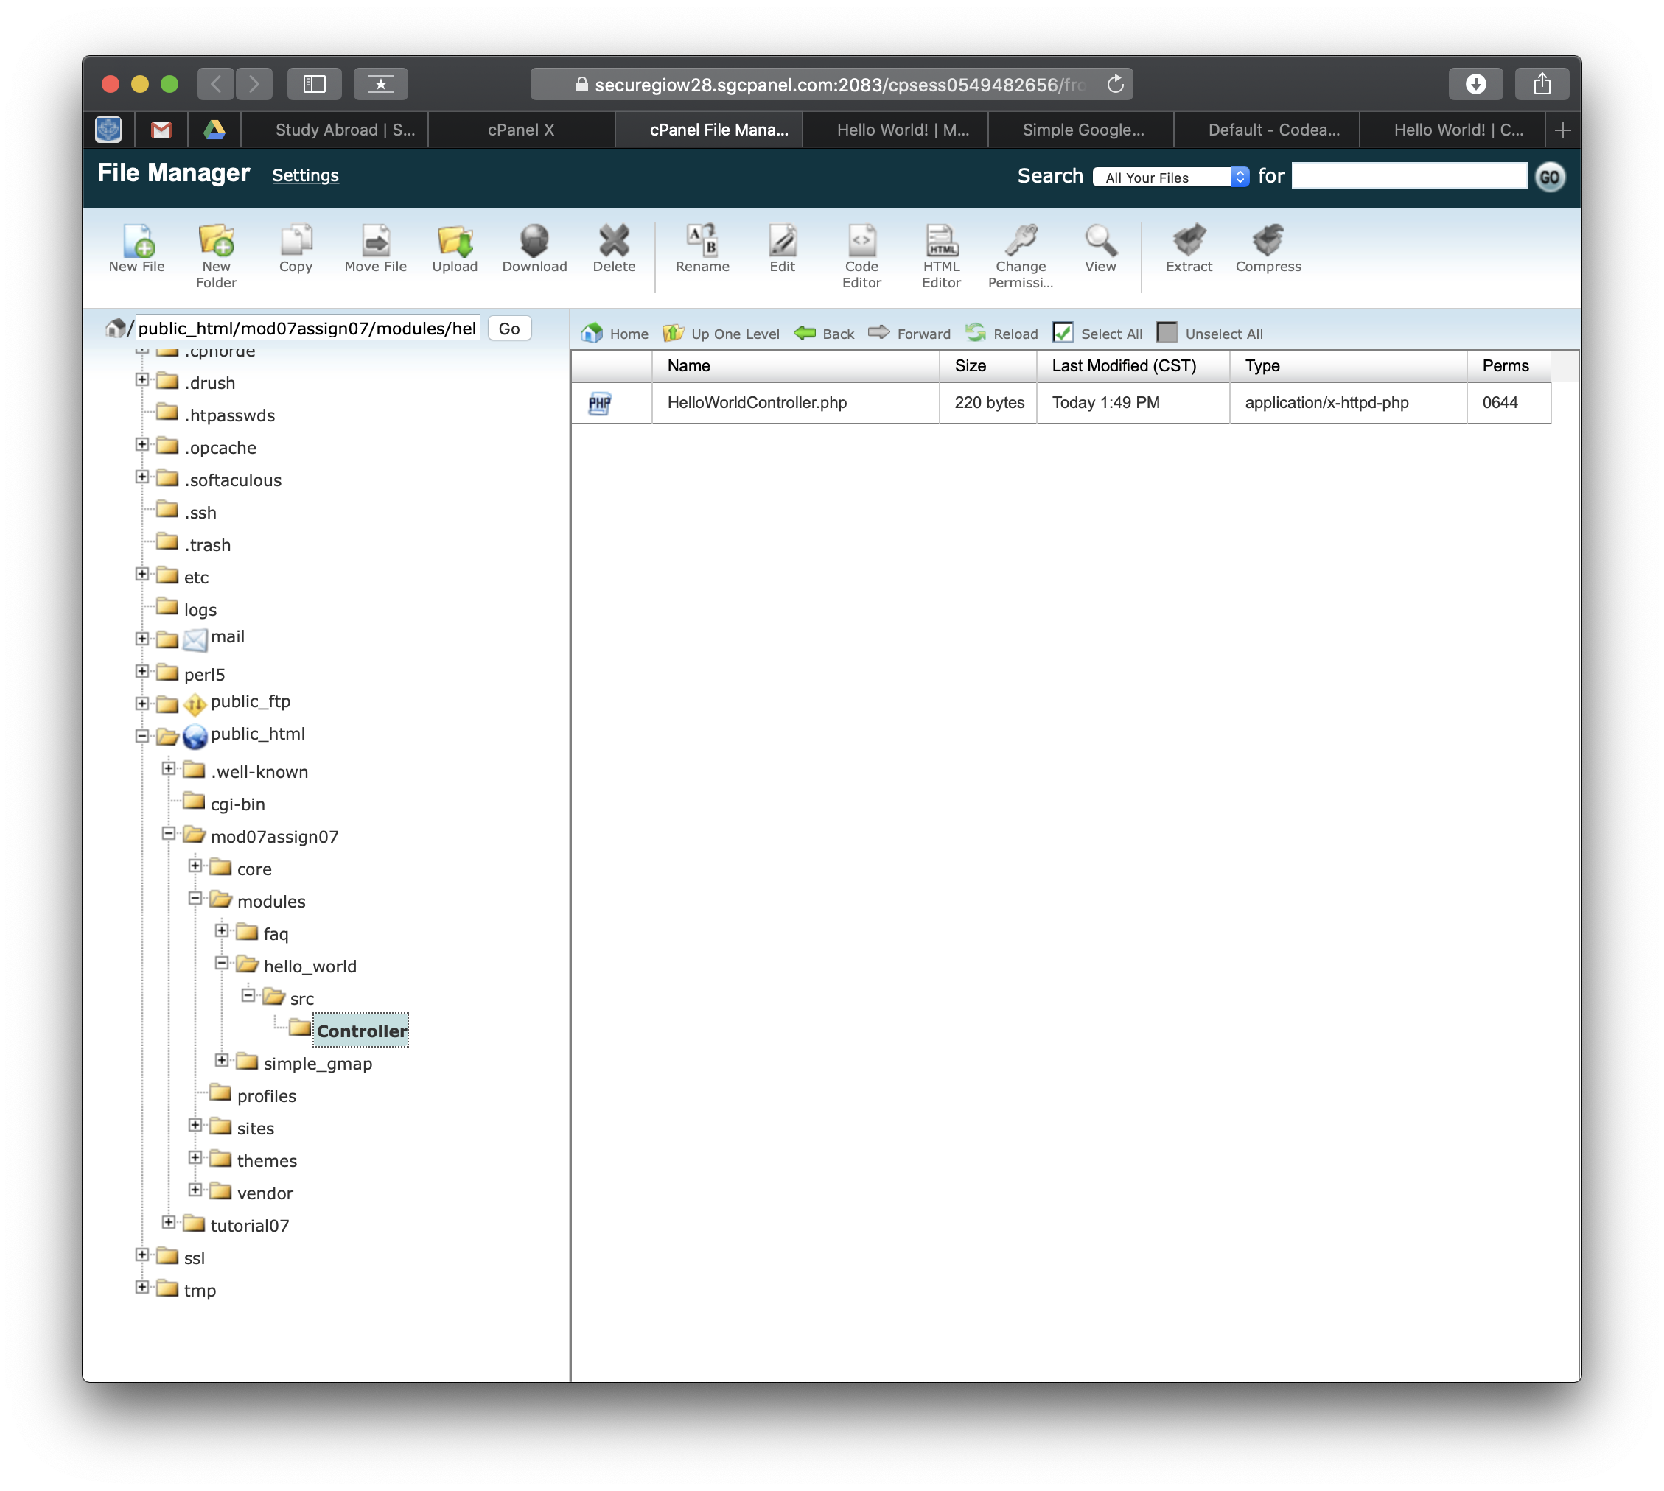]
3. Codeanywhere - SCREEN CAPTURE of the backend with the “/hello/world” appended to the base site URL with the web browser address bar on the picture. [E03][I did both SiteGround and CodeAnywhere in order to get more to know both.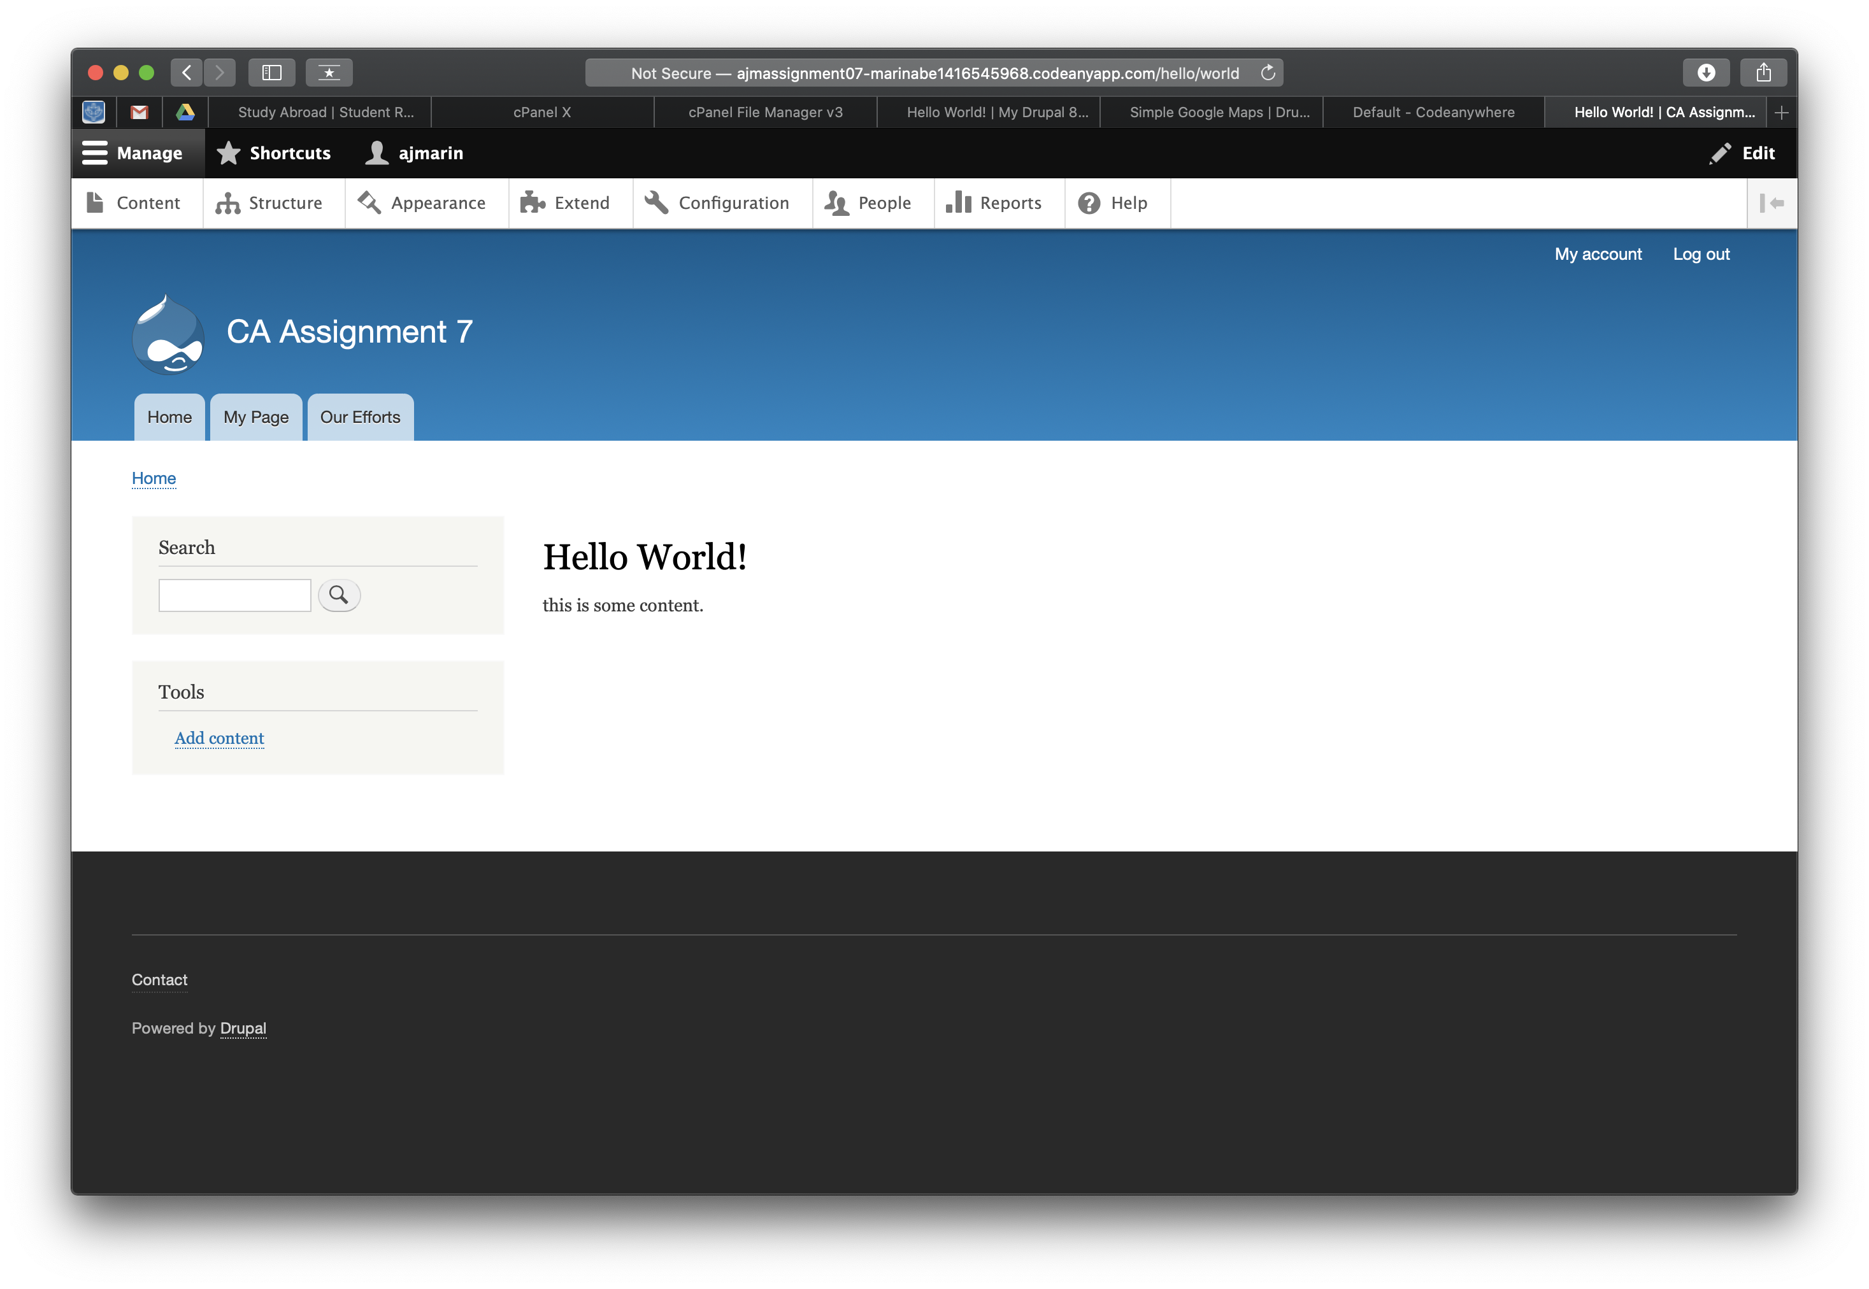]
4. Codeanywhere - File Explorer – take a screen capture of the custom module folder fully expanded. [E04][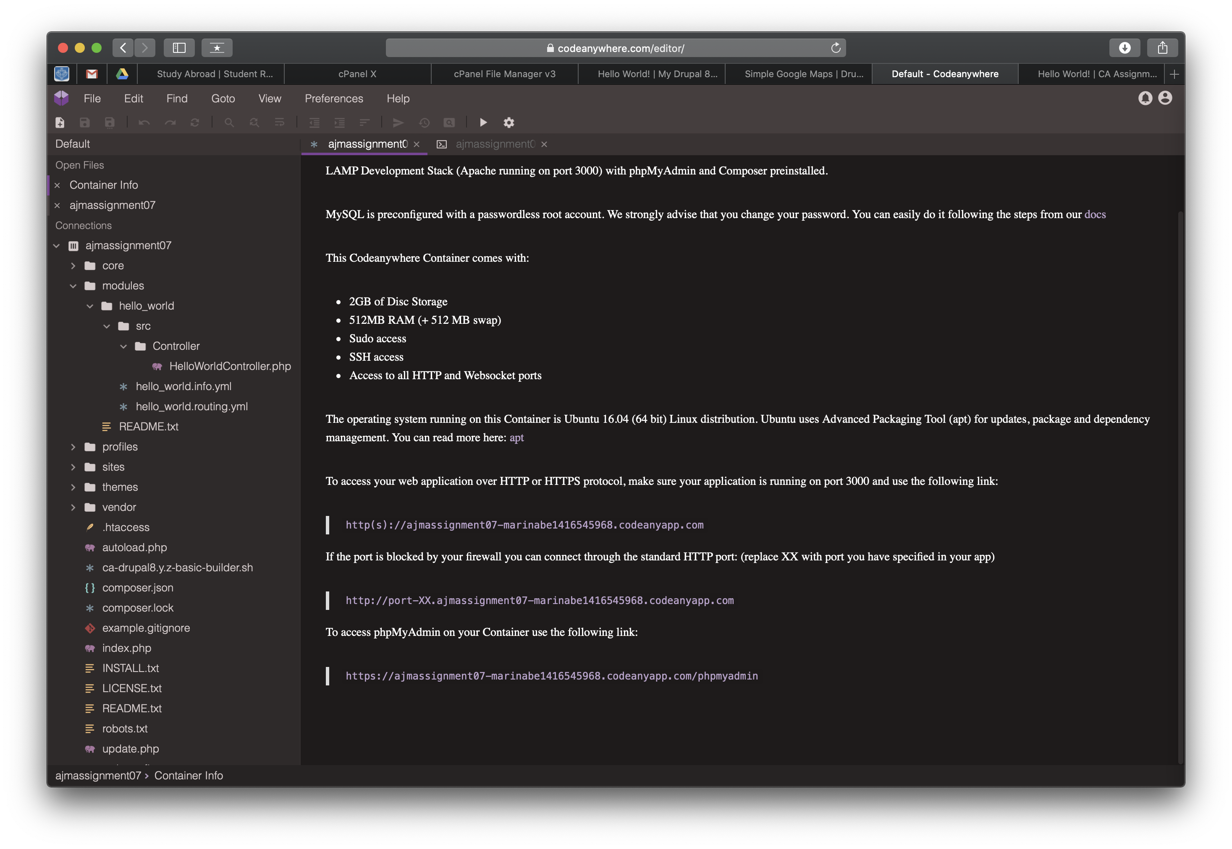]

Go back to the instructions and continue with Part F.

Part F – Drupal 8 Core Fields

1. Write a paragraph on the steps you take to add a Drupal 8 field (like Telephone) to a Drupal 8 content type template structure. [F01][To start off you must first make sure that the field is enabled. You do this by going to Backend Admin toolbar > Extend > Field Types. If it is not, then you must select it then press the install button at the bottom of the page. Otherwise you are fine. Next, you add it to a content type. You do this by going to Backend Admin toolbar > Structure > Content Types. From here you would choose the content type you would like to add the field to by pressing manage fields. Next you would press the + Add field button. From here you would choose the field from either “Add a new field” or “Re-use an existing field” dropdowns. If you chose a field from the “Add a new field” dropdown then you would type in a unique label in the Label text field. Next you press the “Save and continue” button. Finally, if there are any additional settings to change you would change them on the next screen which pops up in the Field Settings. You can also choose to add Help text and/or make the field a required value in the “Edit” tab. From here you can go ahead and create a new node with the new Drupal 8 field. ]
2. What are the differences between adding a new Drupal 8 field verses Re-use an existing field adding to a Drupal 8 content type [F02]  
   [Adding a new Drupal 8 field means that you are creating a new field with a unique machine-readable name. This means that you can’t create a new field with an existing machine-readable name. If you choose to instead re-use an existing field then you don’t have to worry about machine-readable names since the machine-readable name is already unique and just being reused. Though you should still probably give it a Label such as “My Telephone” or “My Image” in order to differentiate between fields that you added.]

Please go back to the instructions and work on the next part.

Part G – Drupal 8 Admin Toolbar Extensions  
1. SCREEN CAPTURE – backend screen capture of your ENHANCED Drupal 8 site Admin toolbar. Please make sure the web browser address bar is visible in your screen capture for full credit. [G01][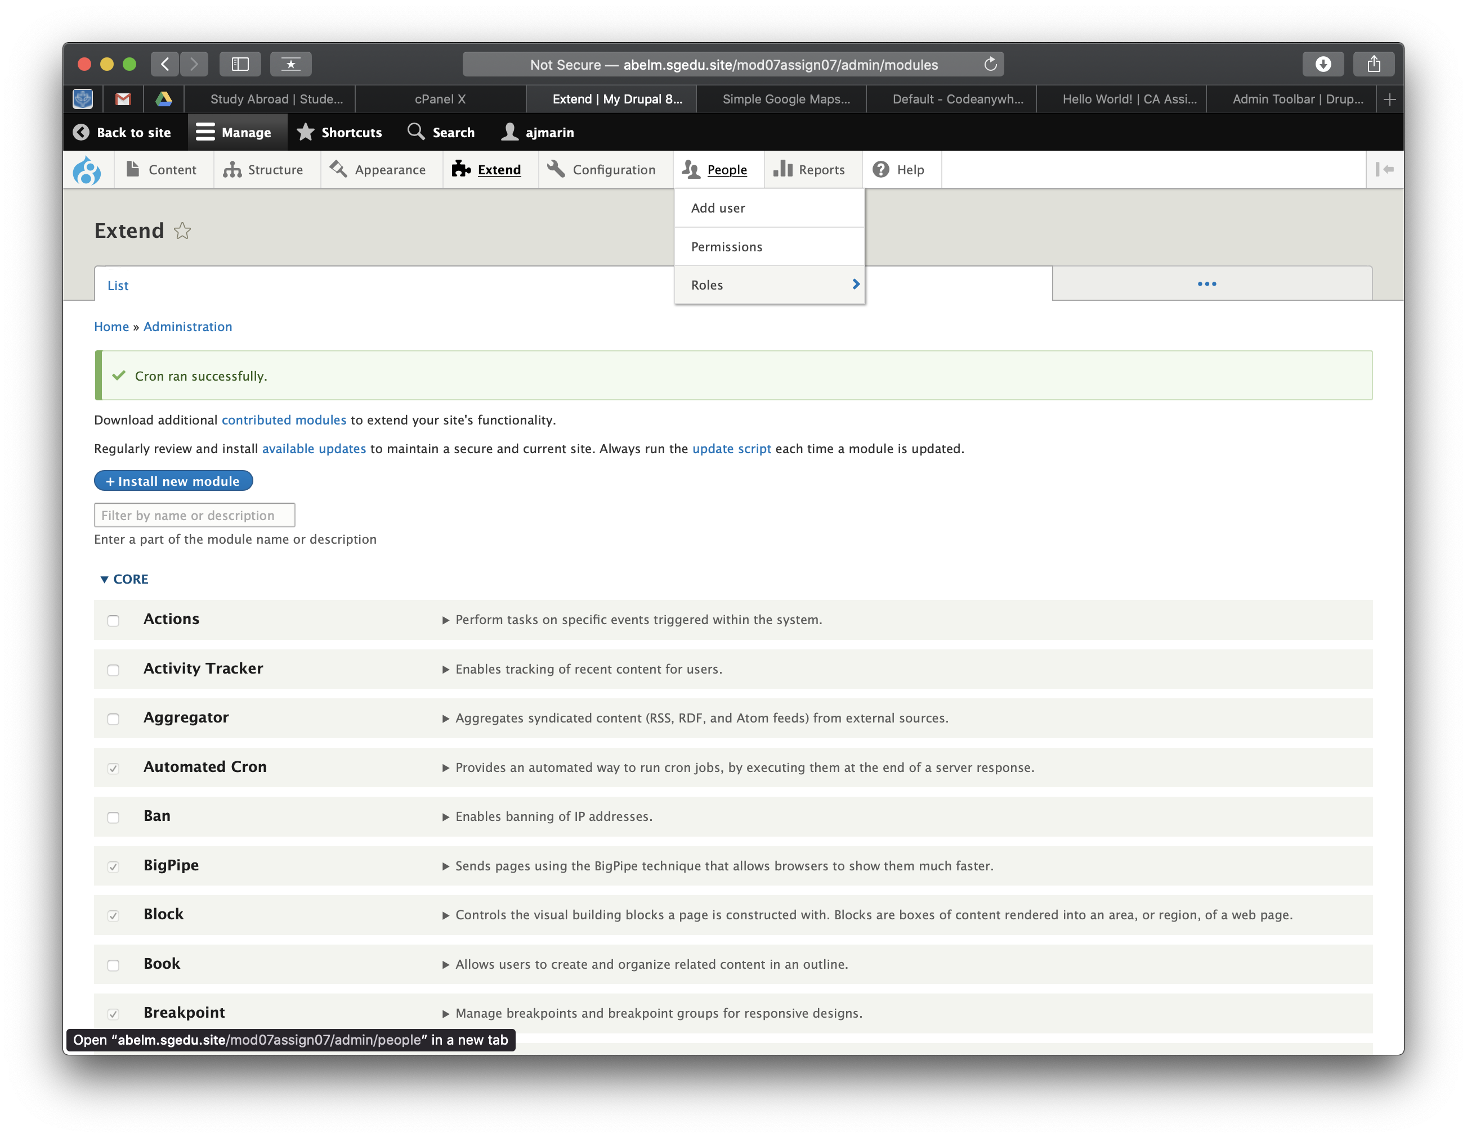]

2. SCREEN CAPTURE – backend screen capture of your Drupal 8 site Admin toolbar enhanced EXTEND page. Please make sure the web browser address bar is visible in your screen capture for full credit.   
[G02][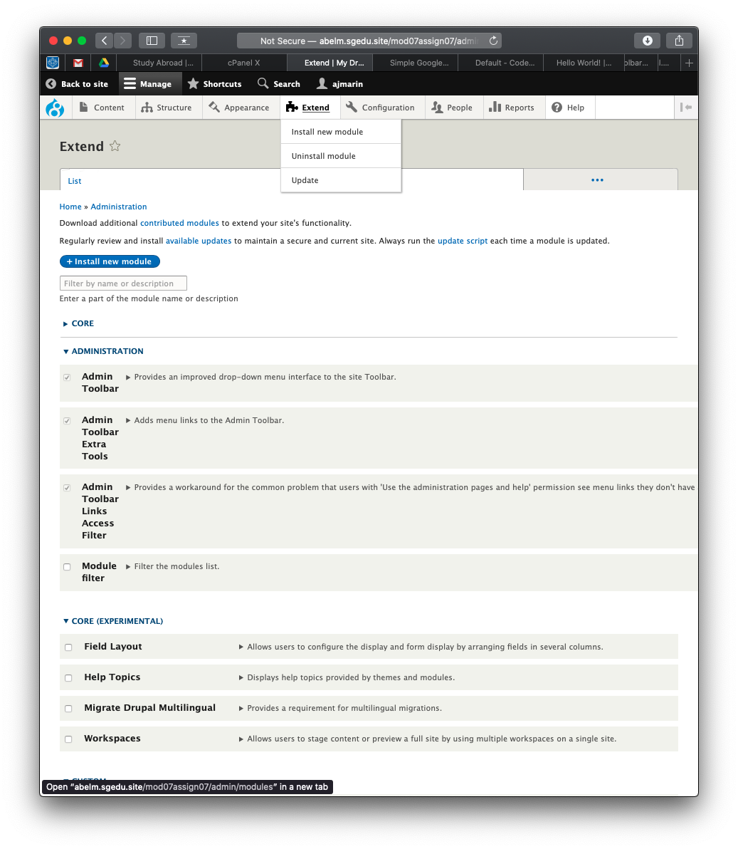]  
Part H – Module Filter - Extend Page Extension  
1. SCREEN CAPTURE – backend screen capture of your Drupal 8 site Admin toolbar while the Extend menu item is selected and at lease 2 CORE module items are visible. Please make sure the web browser address bar is visible in your screen capture for full credit.   
[H01]  
[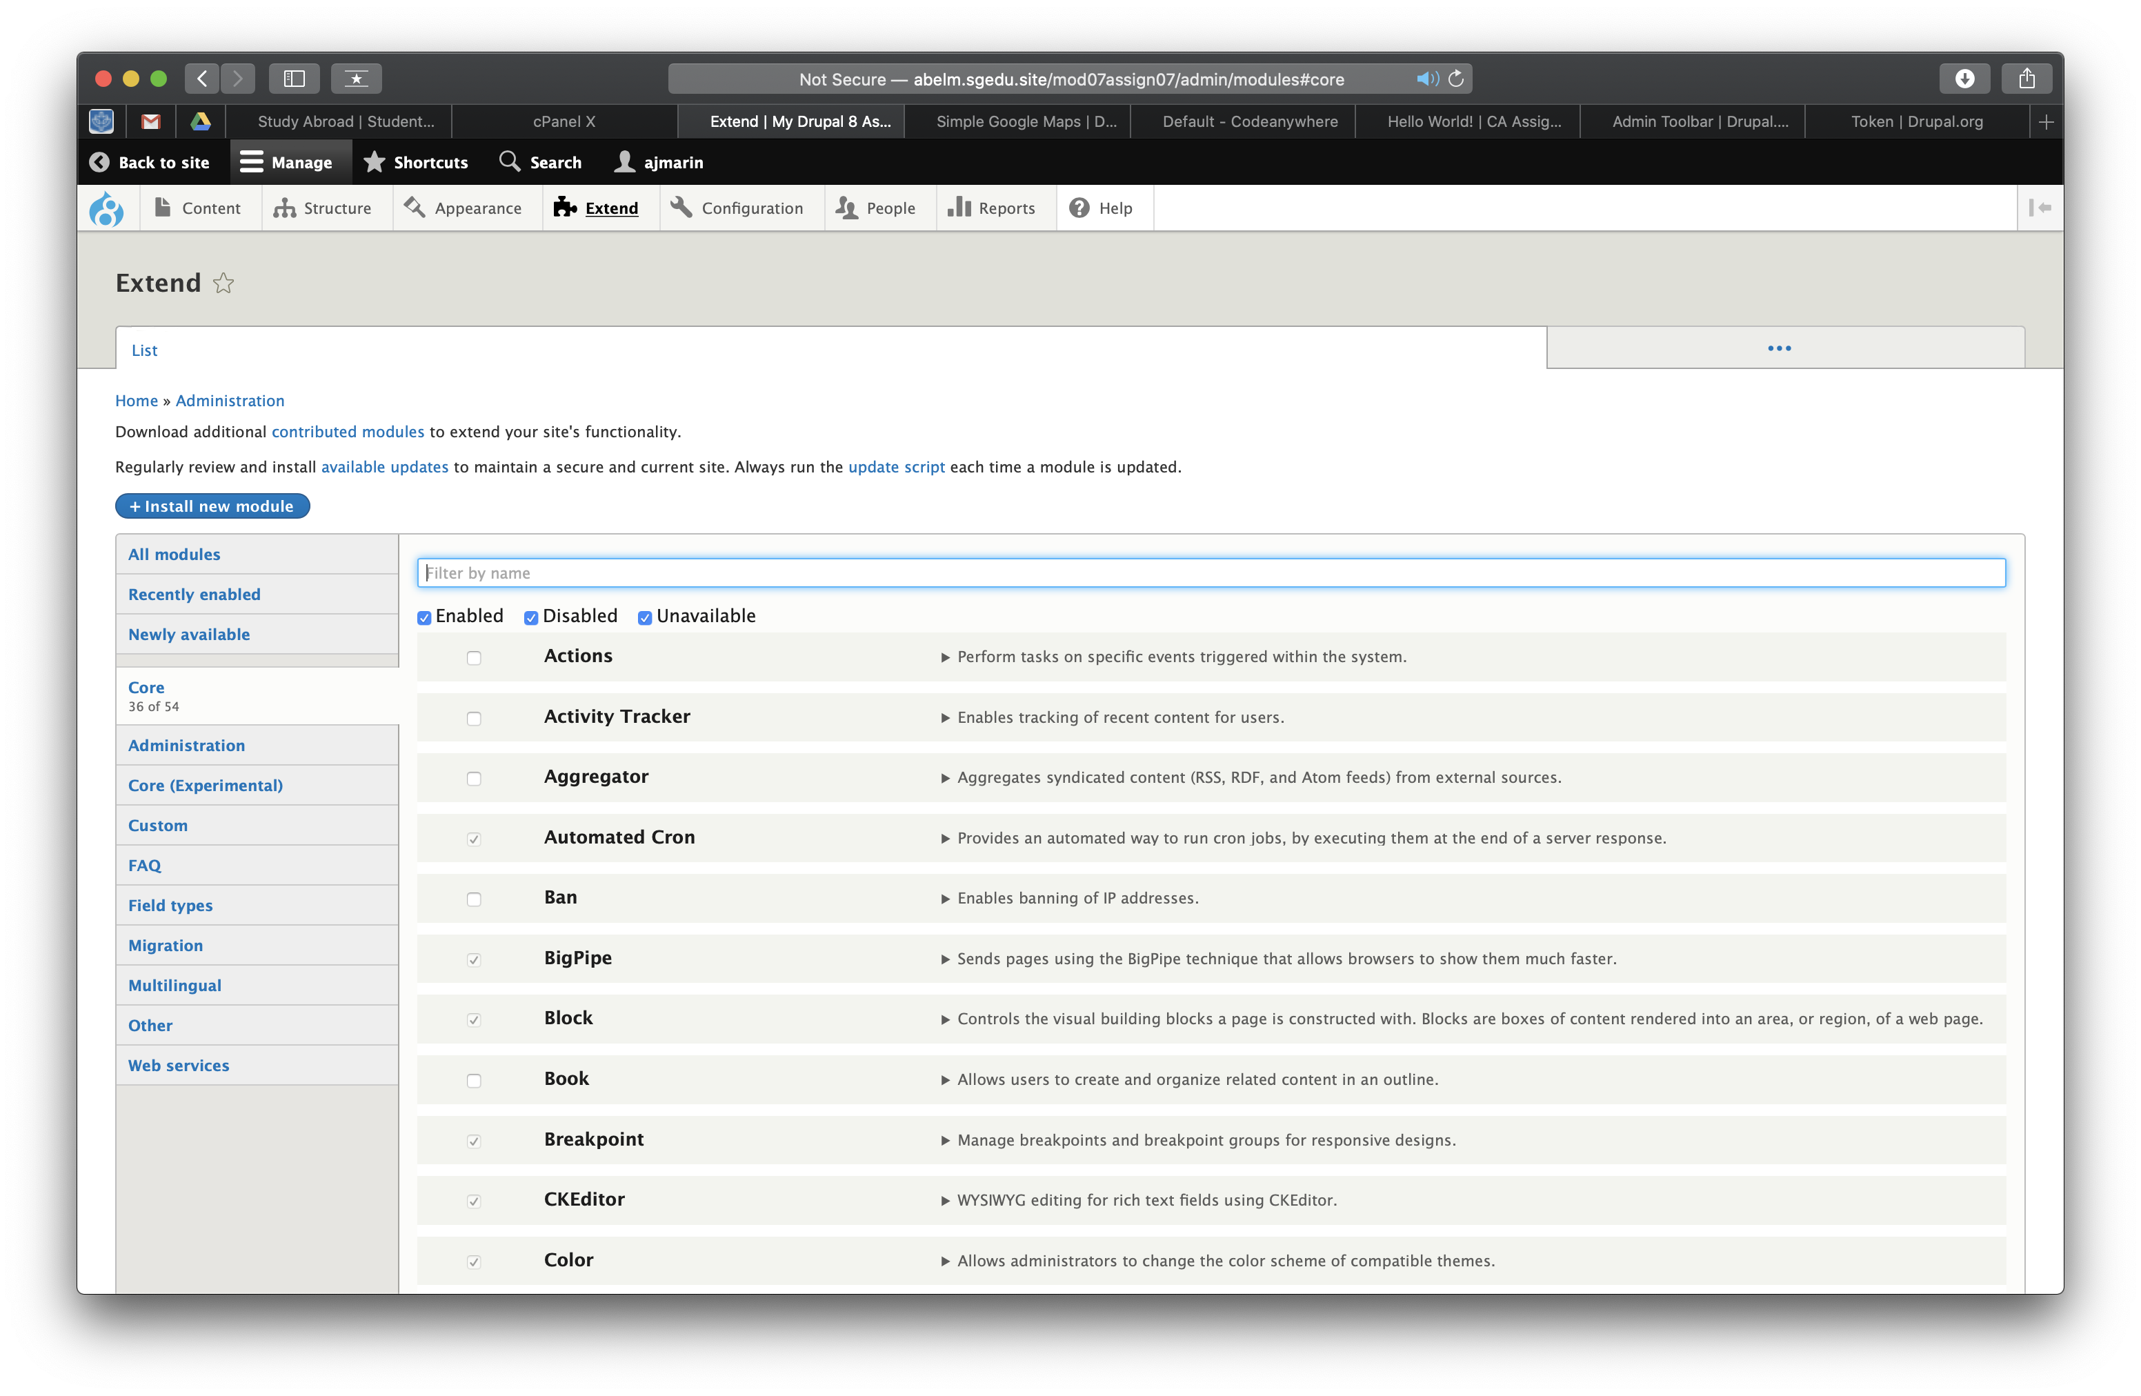]

2. If you did not follow along with the video tutorial and already add the Token module, please do so now.

3. Screen Capture of the Extend page, after searching for “Tok” for the Token module   
[H02]  
[